**Experiment – 1.4**

|  |  |
| --- | --- |
| **Student Name:** Deepak Saini | **UID:** 20BCS4066 |
| **Branch:** 20BCC1 | **Section/Group:** A |
| **Semester:** 5th | **Date of Performance:** 10/09/2022 |
| **Subject Name:** Computer Networks Lab | |
| **Subject Code:** 20CSP-342 | |

**1. Aim of the practical:**

Implementation of Static Routing using 4 routers.

**2. Task to be Done:**

Implementation of Static Routing using 4 routers.

**3. Requirements:**

* PC
* Cisco Packet Tracer Software

**4. Theory:**

A static routing table is created, maintained, and updated by a network administrator, manually. A static route to every network must be configured on every router for full connectivity. This provides a granular level of control over routing but quickly becomes impractical on large networks. Routers will not share static routes with each other, thus reducing CPU/RAM overhead and saving bandwidth. However, static routing is not fault-tolerant, as any change to the routing infrastructure (such as a link going down, or a new network added) requires manual intervention. Routers operating in a purely static environment cannot seamlessly choose a better route if a link becomes unavailable. Static routes have an Administrative Distance (AD) of 1, and thus are always preferred over dynamic routes, unless the default AD is changed. A static route with an adjusted AD is called a floating static route.

**5. Steps and snapshots of the practical:**

a. Open the Cisco packet tracer application on your PC and login with your credentials.

b. Create four different computer networks and each network consists of two end devices(PCs), and a network device which is Switch.

c. Router works on network layer that enables two different networks to communicate in between these two sets of PC-Switch-PC connections as well as between router and router, so we need to add 4 network devices (Router) and connect each router in the following manner which is defined below :

**I. Router 1:**

i) Connect the one end of the router 1 with switch 0 with the help of Copper Straight Through wire

and other end of the router 1 with the router 2 with the help of Copper Straight Through wire.

Establish a connection using the straight through wire selection. Select Gigabit Ethernet option in Switch Gig 0/1 and in Router Gig 0/0/0 for one network, on other network, select Router Gig 0/0/1 connections. This is done to avoid default fast ethernet for switch and Gigabit for Router.

ii) Provide IP configuration to PCs and rename them with same. IP of the PCs should vary in both the networks. Here Router should be provided with IP addresses corresponding to the network it is connected to. Router->Config->

• Gigabit 0/0/0-> IP of 192.168.1.3

• Gigabit 0/0/1-> IP of 192.168.4.1

• Switch ON both the interfaces.

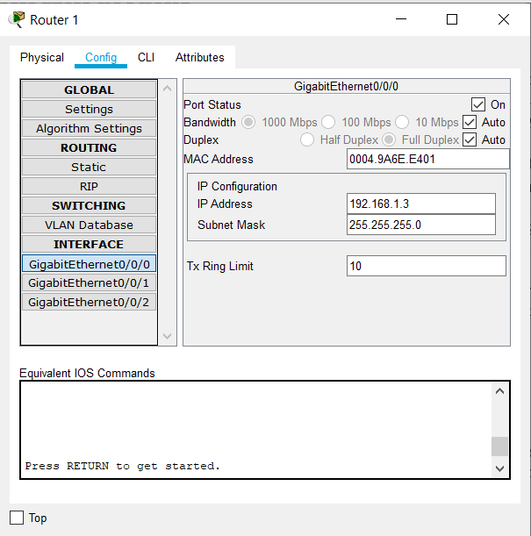 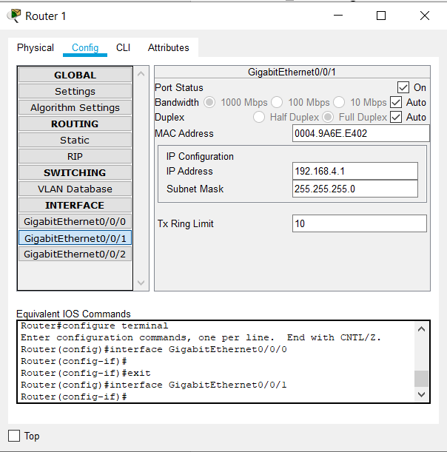

iii) Put IP of Router's corresponding ethernet connection in the PCs default gateway option in IP configuration. This is for switches to recognize the gateway to send message in another network.

PC-> Desktop->IP Config->Default gateway-> 192.168.1.3 in left networks.

iv) To send messages to different networks which are not directly connected to the router, we need to perform the following steps:

Router->Config->Routing->Static

In the static routes :

Network -> We need to put the network IP address of all the other networks which are not directly connected to the particular router and at the last set of the IP address(Host Portion) we need to put 0 among all networks.

Mask -> We need to provide Subnet mask as 255.255.255.0 to all the networks we want to add.

Next Hop-> A next hop IP is the IP address of a adjacent router or device with layer-2 connectivity to the managed device. The next hop is among the series of routers that are connected together in a network and is the next possible destination for a data packet. So we need to provide the Hop of just neighboring router(left or right) according to next possible destination for a data packet.

So for router 1:

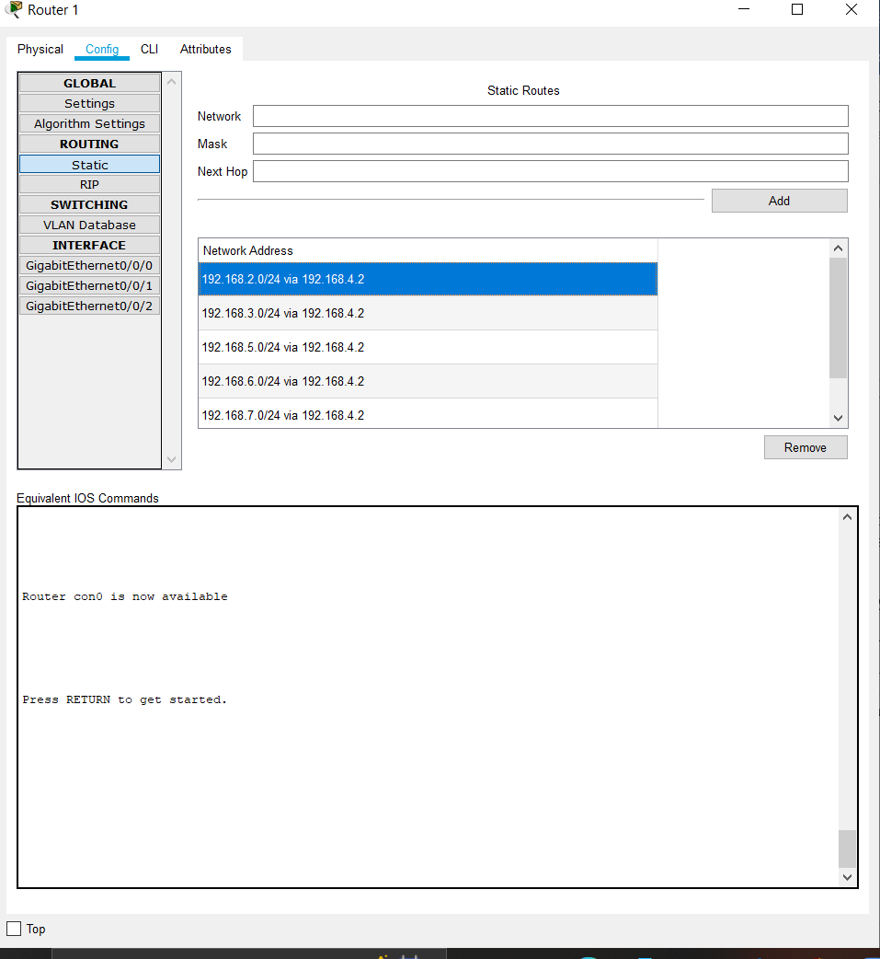

**II. Router 2:**

i) Click on Router 2 and zoom in, switch it OFF and add a Serial port (Synchronous Serial NIM 2T port) from bottom left corner in the router. Switch it ON again.

ii) Create Serial connection (Serial 0/1/0) using the Serial DTE wire selection between Router 2 and 3. The connection between the routers is also a network so we have 7 networks in total.

iii) Connect the one end of the router 2 with switch 1 with the help of Copper Straight Through wire

and other end of the router 2 with the router 3 with the help of Serial DTE wire.

Establish a connection using the straight through wire selection. Select Gigabit Ethernet option in Switch Gig 0/1 and in Router Gig 0/0/0 for one network, on other network, select Router Gig 0/0/1 connections. This is done to avoid default fast ethernet for switch and Gigabit for Router. Also select Serial 0/1/0.

iv) Provide IP configuration to PCs and rename them with same. IP of the PCs should vary in both the networks. Here Router should be provided with IP addresses corresponding to the network it is connected to. Router->Config->

• Gigabit 0/0/0-> IP of 192.168.2.3

• Gigabit 0/0/1-> IP of 192.168.4.2

* Serial 0/1/0 -> IP of 192.168.5.1

• Switch ON both the interfaces.

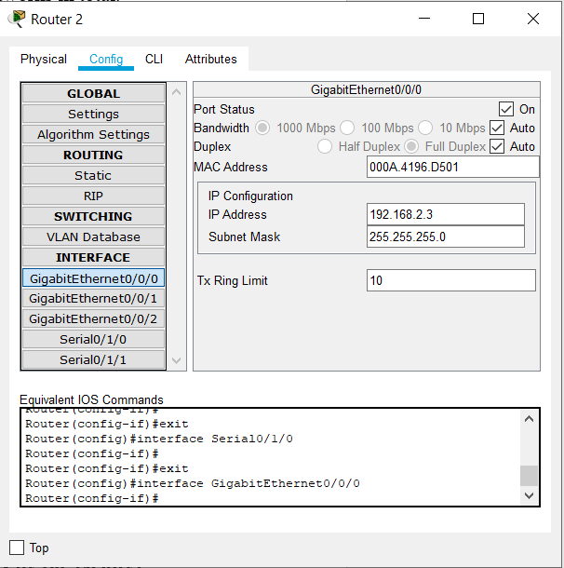 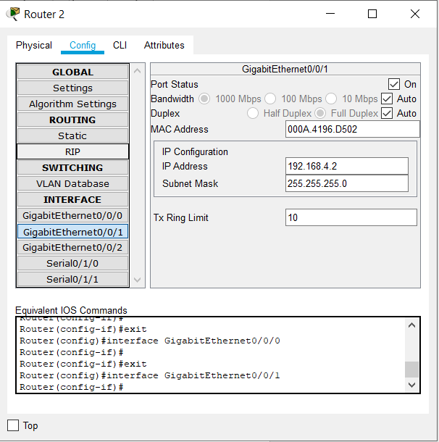

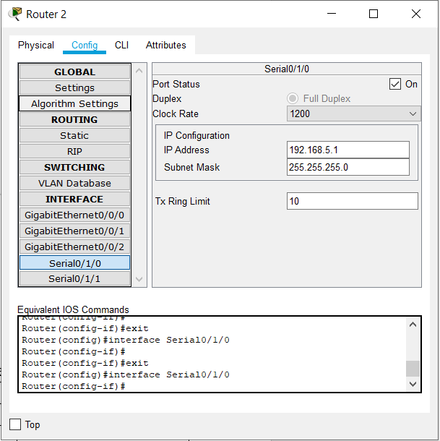

v) Put IP of Router's corresponding ethernet connection in the PCs default gateway option in IP configuration. This is for switches to recognize the gateway to send message in another network.

PC-> Desktop->IP Config->Default gateway-> 192.168.2.3 in 2nd networks.

vi) To send messages to different networks which are not directly connected to the router, we need to perform the following steps:

Router->Config->Routing->Static

In the static routes :

Network -> We need to put the network IP address of all the other networks which are not directly connected to the particular router and at the last set of the IP address(Host Portion) we need to put 0 among all networks.

Mask -> We need to provide Subnet mask as 255.255.255.0 to all the networks we want to add.

Next Hop-> A next hop IP is the IP address of a adjacent router or device with layer-2 connectivity to the managed device. The next hop is among the series of routers that are connected together in a network and is the next possible destination for a data packet. So we need to provide the Hop of just neighboring router(left or right) according to next possible destination for a data packet.

So for router 2:

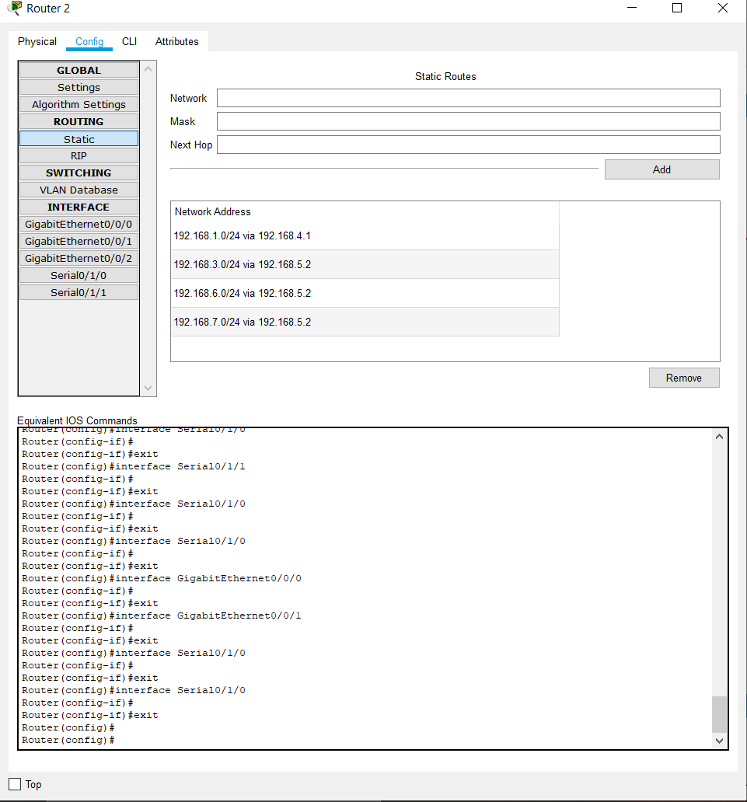

**III. Router 3:**

i) Click on Router 3 and zoom in, switch it OFF and add a Serial port (Synchronous Serial NIM 2T port) from bottom left corner in the router. Switch it ON again.

ii) Create Serial connection (Serial 0/1/0) using the Serial DTE wire selection between Router 2 and 3. The connection between the routers is also a network so we have 7 networks in total.

iii) Connect the one end of the router 3 with switch 2 with the help of Copper Straight Through wire

and other end of the router 2 with the router 3 with the help of Serial DTE wire.

Establish a connection using the straight through wire selection. Select Gigabit Ethernet option in Switch Gig 0/1 and in Router Gig 0/0/0 for one network, on other network, select Router Gig 0/0/1 connections. This is done to avoid default fast ethernet for switch and Gigabit for Router. Also select Serial 0/1/0.

iv) Provide IP configuration to PCs and rename them with same. IP of the PCs should vary in both the networks. Here Router should be provided with IP addresses corresponding to the network it is connected to. Router->Config->

• Gigabit 0/0/0-> IP of 192.168.3.3

• Gigabit 0/0/1-> IP of 192.168.7.1

* Serial 0/1/0 -> IP of 192.168.5.2

• Switch ON both the interfaces.

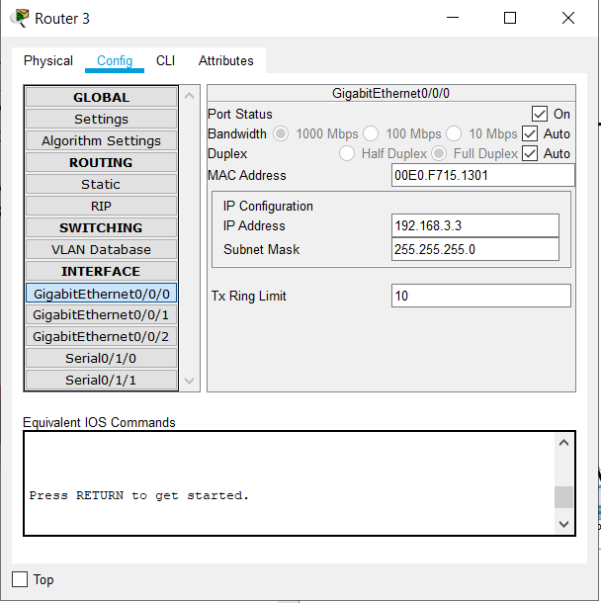 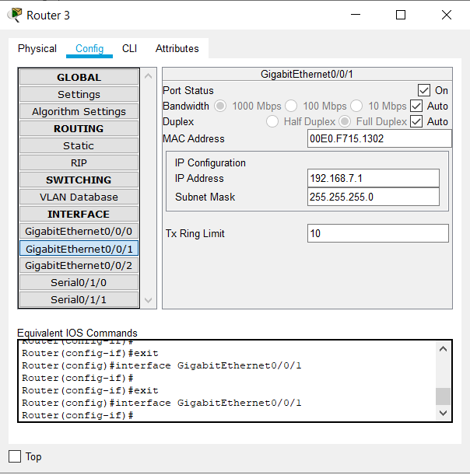

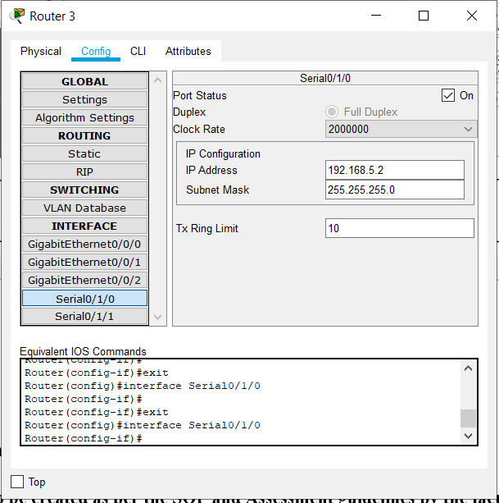

v) Put IP of Router's corresponding ethernet connection in the PCs default gateway option in IP configuration. This is for switches to recognize the gateway to send message in another network.

PC-> Desktop->IP Config->Default gateway-> 192.168.3.3 in 2nd networks.

vi) To send messages to different networks which are not directly connected to the router, we need to perform the following steps:

Router->Config->Routing->Static

In the static routes :

Network -> We need to put the network IP address of all the other networks which are not directly connected to the particular router and at the last set of the IP address(Host Portion) we need to put 0 among all networks.

Mask -> We need to provide Subnet mask as 255.255.255.0 to all the networks we want to add.

Next Hop-> A next hop IP is the IP address of a adjacent router or device with layer-2 connectivity to the managed device. The next hop is among the series of routers that are connected together in a network and is the next possible destination for a data packet. So we need to provide the Hop of just neighboring router(left or right) according to next possible destination for a data packet.

So for router 3:

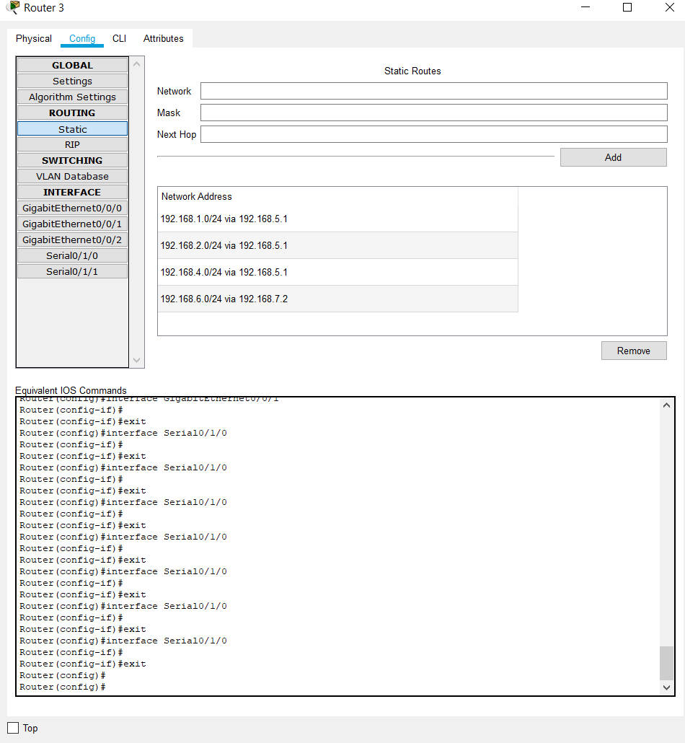

**IV. Router 4:**

i) Connect the one end of the router 4 with switch 3 with the help of Copper Straight Through wire

and other end of the router 4 with the router 3 with the help of Copper Straight Through wire.

Establish a connection using the straight through wire selection. Select Gigabit Ethernet option in Switch Gig 0/1 and in Router Gig 0/0/0 for one network, on other network, select Router Gig 0/0/1 connections. This is done to avoid default fast ethernet for switch and Gigabit for Router.

ii) Provide IP configuration to PCs and rename them with same. IP of the PCs should vary in both the networks. Here Router should be provided with IP addresses corresponding to the network it is connected to. Router->Config->

• Gigabit 0/0/0-> IP of 192.168.6.3

• Gigabit 0/0/1-> IP of 192.168.7.2

• Switch ON both the interfaces.

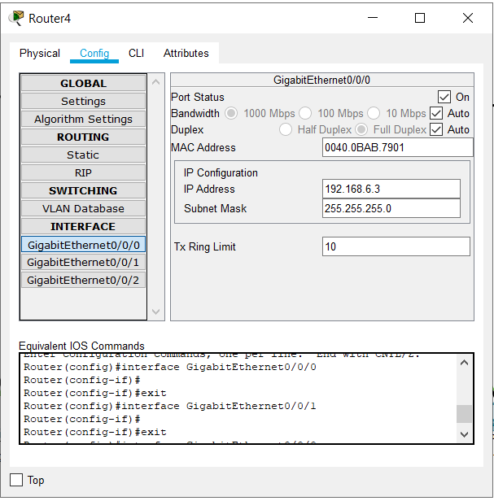 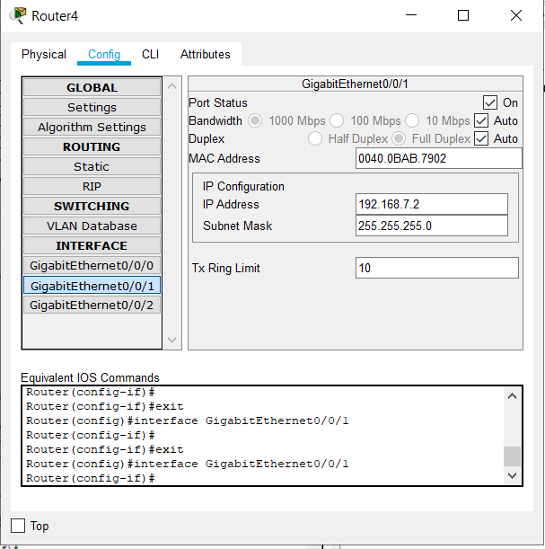

iii) Put IP of Router's corresponding ethernet connection in the PCs default gateway option in IP configuration. This is for switches to recognize the gateway to send message in another network.

PC-> Desktop->IP Config->Default gateway-> 192.168.6.3 in right networks.

iv) To send messages to different networks which are not directly connected to the router, we need to perform the following steps:

Router->Config->Routing->Static

In the static routes :

Network -> We need to put the network IP address of all the other networks which are not directly connected to the particular router and at the last set of the IP address(Host Portion) we need to put 0 among all networks.

Mask -> We need to provide Subnet mask as 255.255.255.0 to all the networks we want to add.

Next Hop-> A next hop IP is the IP address of a adjacent router or device with layer-2 connectivity to the managed device. The next hop is among the series of routers that are connected together in a network and is the next possible destination for a data packet. So we need to provide the Hop of just neighboring router(left or right) according to next possible destination for a data packet.

So for router 4:

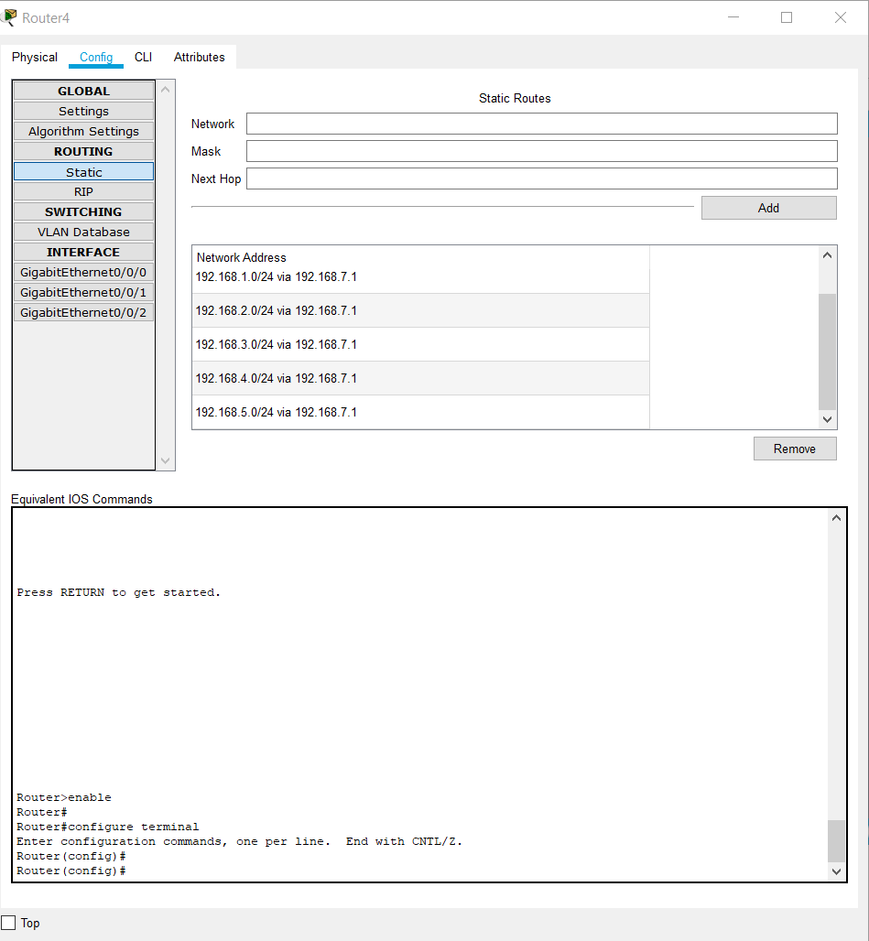

d)Now select the message option and drop on sender and receiver and devices one by one. First packet will get failed because connection was not yet configured. Thereafter all other packets are sent successfully

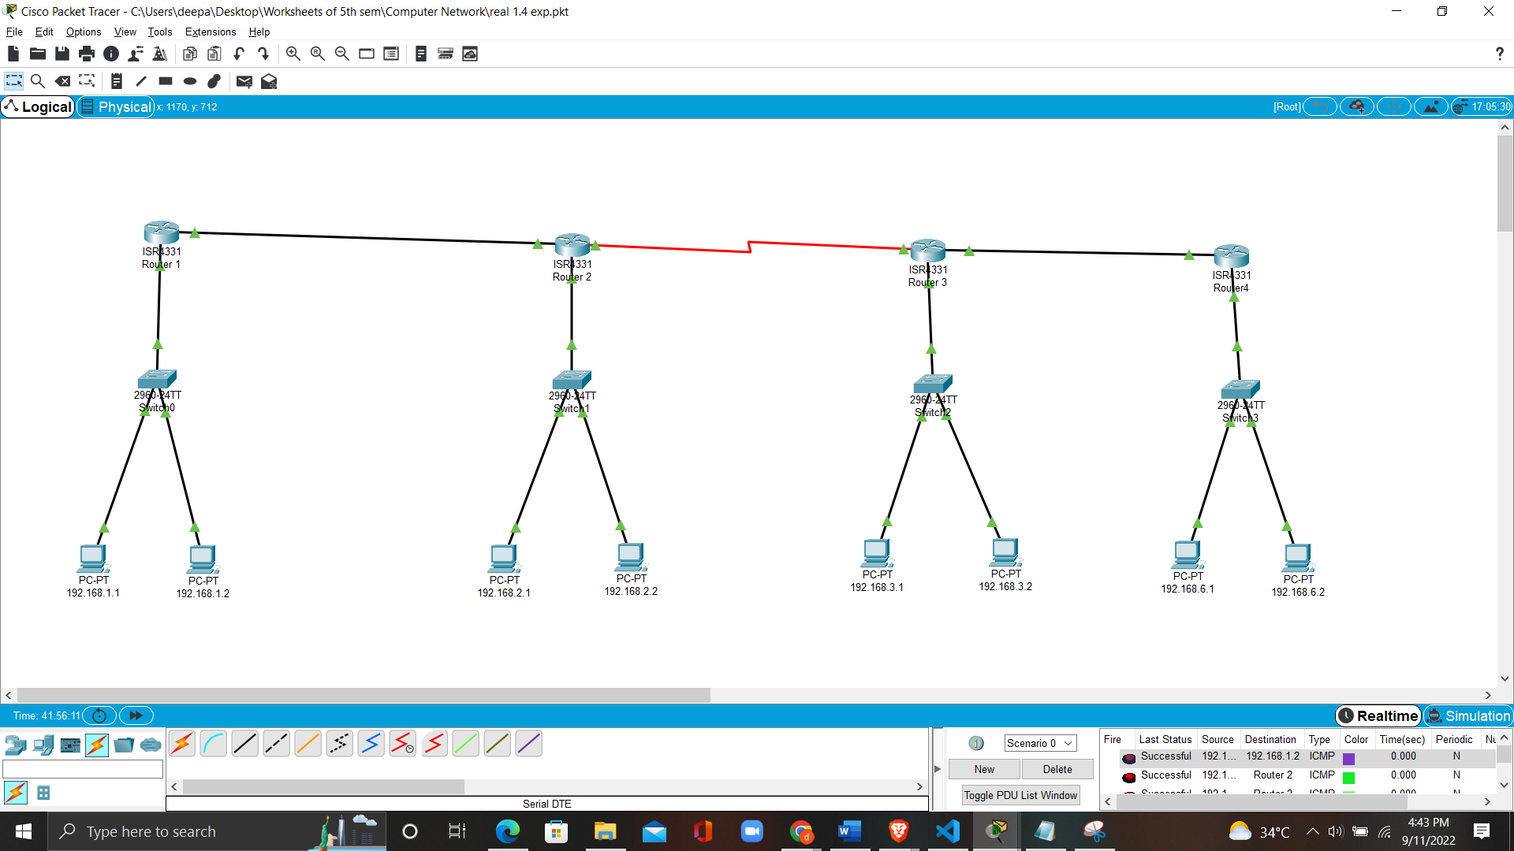

e) Try pinging PCs in different networks through command prompt. • PC-> Desktop->Command prompt ->ping Four packets are sent out of which first packet shows Request timed out as connection was not yet configured. Rest all are successful thereafter.

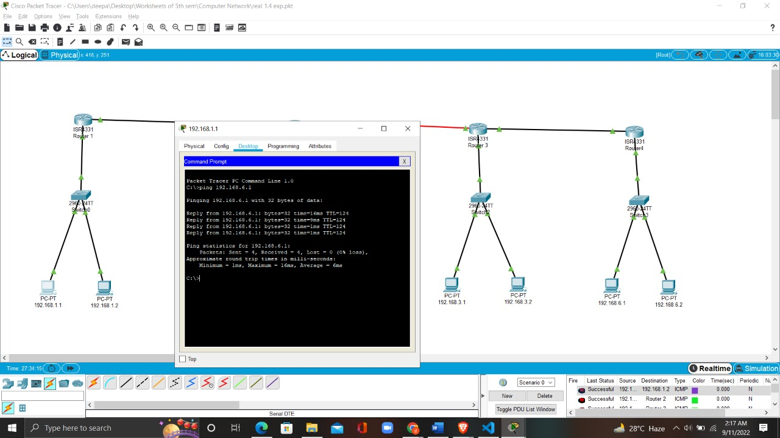

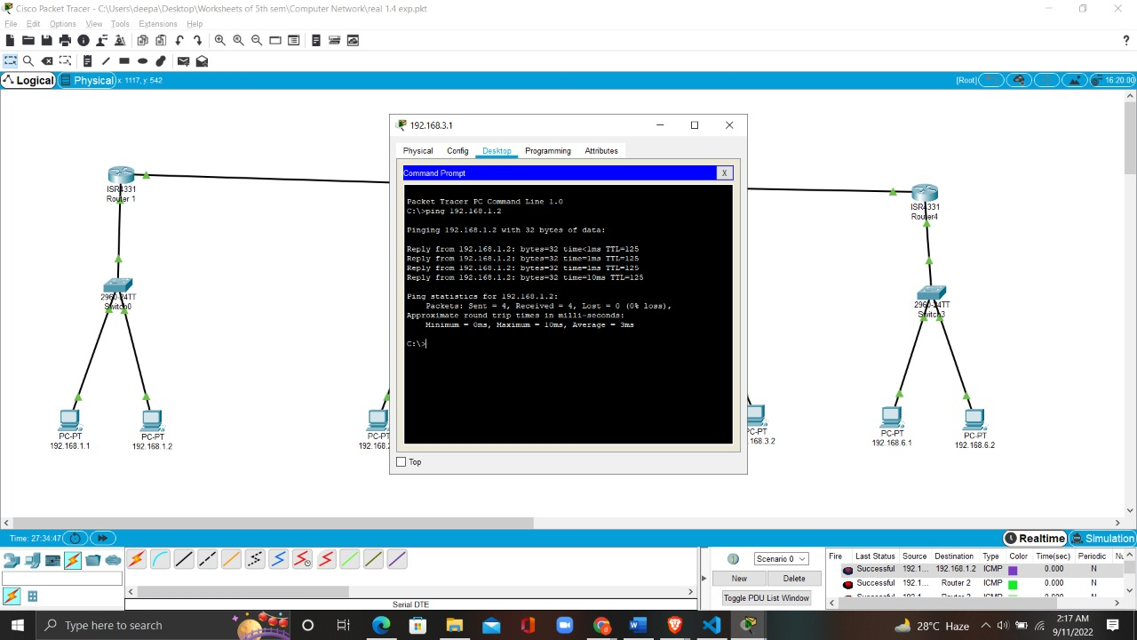

**6. Learning Outcomes:**

• To successfully understand the basic networking concepts.

• To learn about working on Cisco Packet Tracer.

• To build a basic computer network using the components in a network.

* How static routing is created , maintained and updated by a network administrator using static route.

**Evaluation Grid (To be created as per the SOP and Assessment guidelines by the faculty):**

|  |  |  |  |
| --- | --- | --- | --- |
| Sr. No. | Parameters | Marks Obtained | Maximum Marks |
| 1. |  |  |  |
| 2. |  |  |  |
| 3. |  |  |  |